Assignment

**Htno : 2503A52L11**

**Lab 7**: Error Debugging with AI – Systematic Approaches to Finding and Fixing Bugs

**Lab Objectives:**

* To identify and correct syntax, logic, and runtime errors in Python programs using AI tools.
* To understand common programming bugs and AI-assisted debugging suggestions.
* To evaluate how AI explains, detects, and fixes different types of coding errors.
* To build confidence in using AI to perform structured debugging practices.

**Lab Outcomes (LOs):**

After completing this lab, students will be able to:

* Use AI tools to detect and correct syntax, logic, and runtime errors.
* Interpret AI-suggested bug fixes and explanations.
* Apply systematic debugging strategies supported by AI-generated insights.
* Refactor buggy code using responsible and reliable programming patterns.

1. **Task Description #1:**

Introduce a buggy Python function that calculates the factorial of a number using recursion. Use Copilot or Cursor AI to detect and fix the logical or syntax errors.

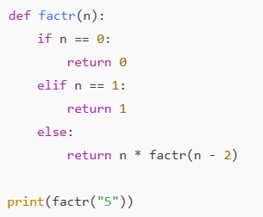

**Expected Outcome #1:**

* Copilot or Cursor AI correctly identifies missing base condition or incorrect recursive call and suggests a functional factorial implementation.

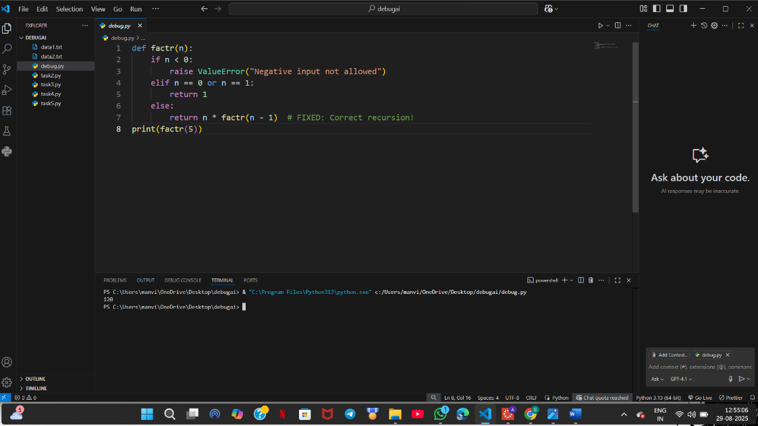

**Task Description #2:**

* Provide a list sorting function that fails due to a type error (e.g., sorting list with mixed integers and strings). Prompt AI to detect the issue and fix the code for consistent sorting**.**

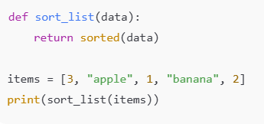

**Expected Outcome #2:**

* AI detects the type inconsistency and either filters or converts list elements, ensuring successful sorting without a crash.

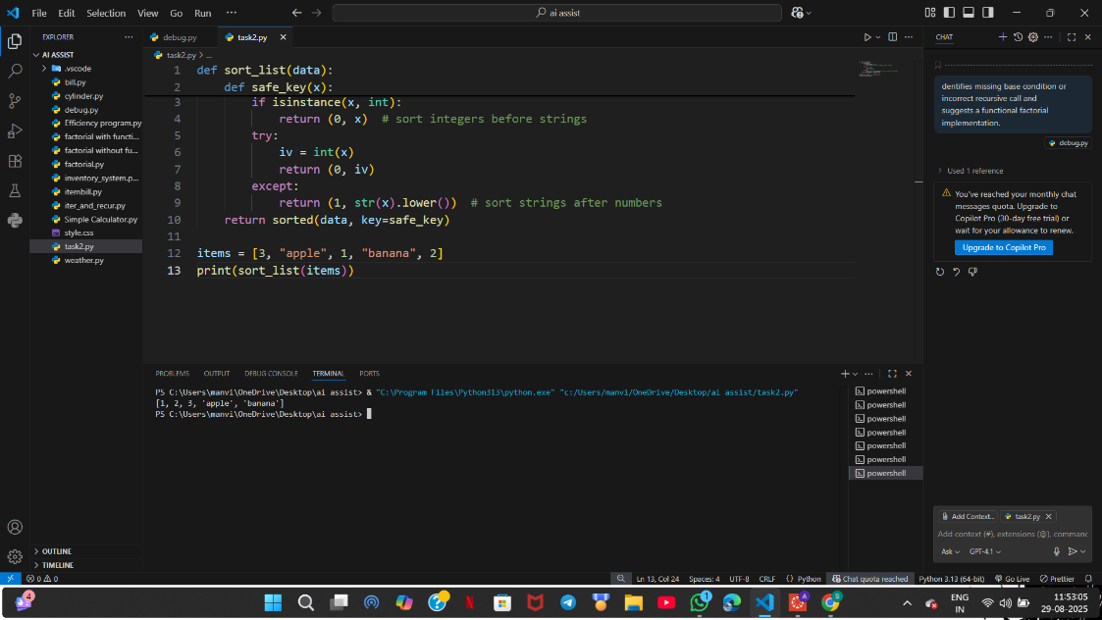

**Task Description #3:**

* Write a Python snippet for file handling that opens a file but forgets to close it. Ask Copilot or Cursor AI to improve it using the best practice (e.g., with open() block).

**Code1**



**Code2**

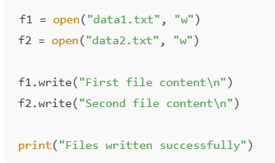

**Code3**

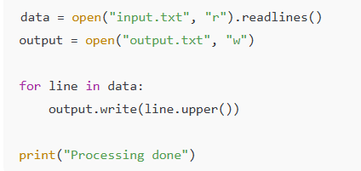

**Code4:**

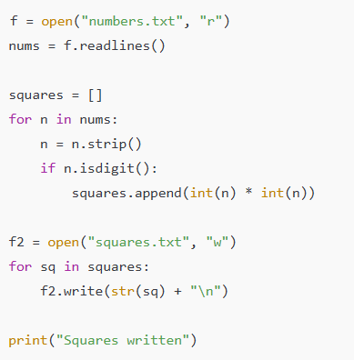

**Expected Outcome #3:**

* AI refactors the code to use a context manager, preventing resource leakage and runtime warnings.

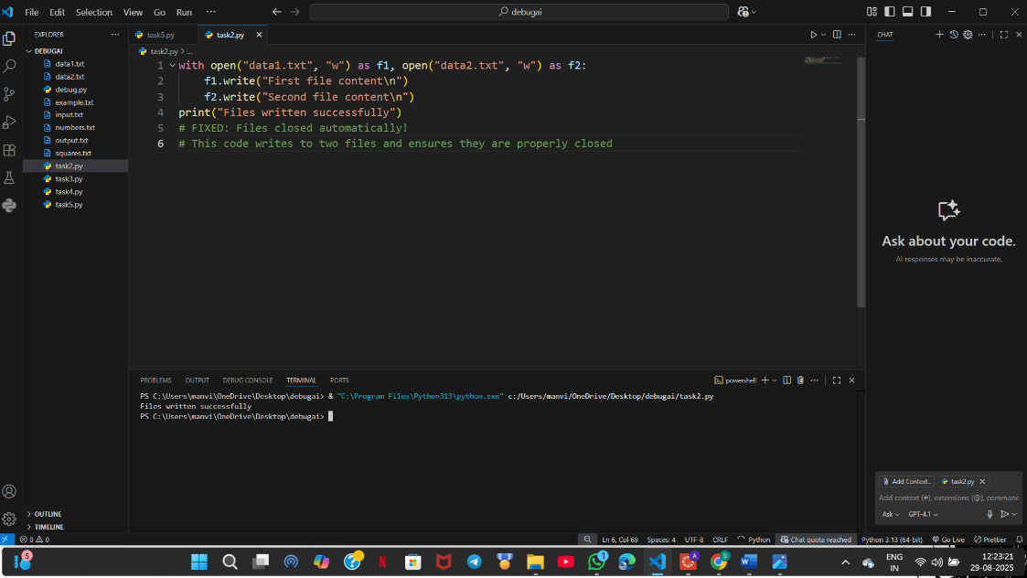

* **File one :**

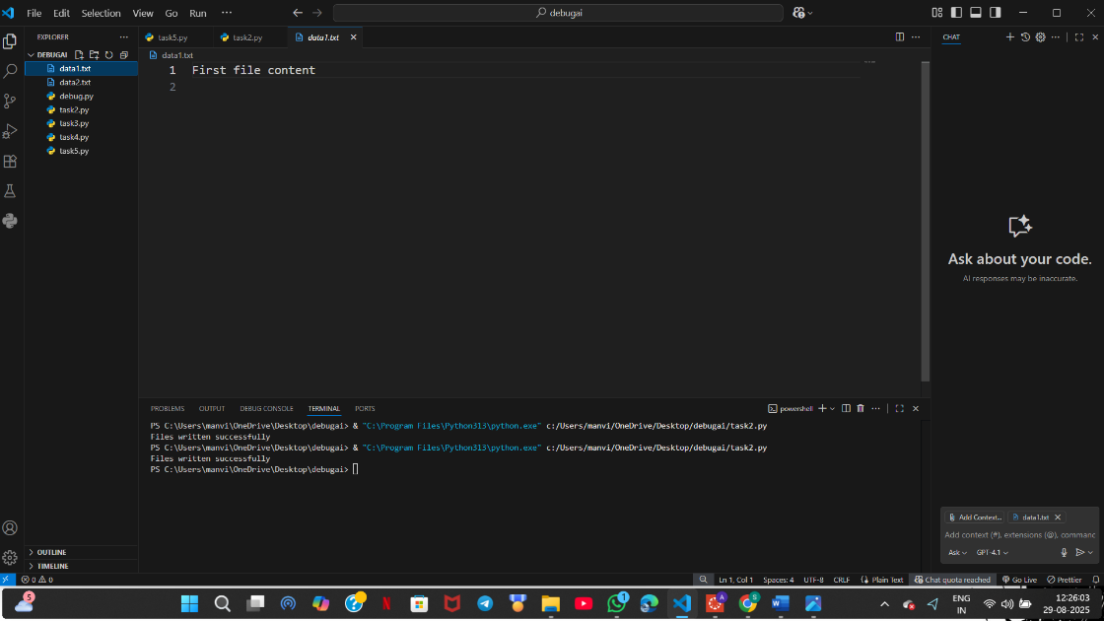

* **File Two :**

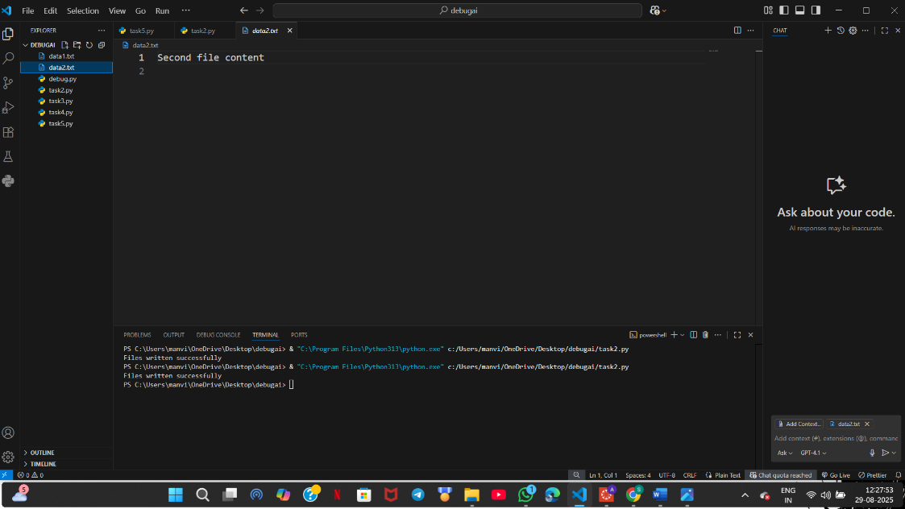

**Task Description #4:**

* Provide a piece of code with a ZeroDivisionError inside a loop. Ask AI to add error handling using try-except and continue execution safely.

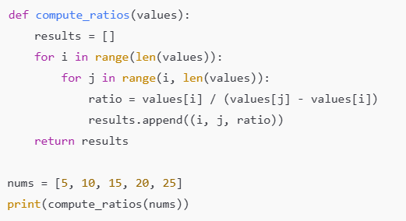

**Expected Outcome #4:**

* Copilot adds a try-except block around the risky operation, preventing crashes and printing a meaningful error message.

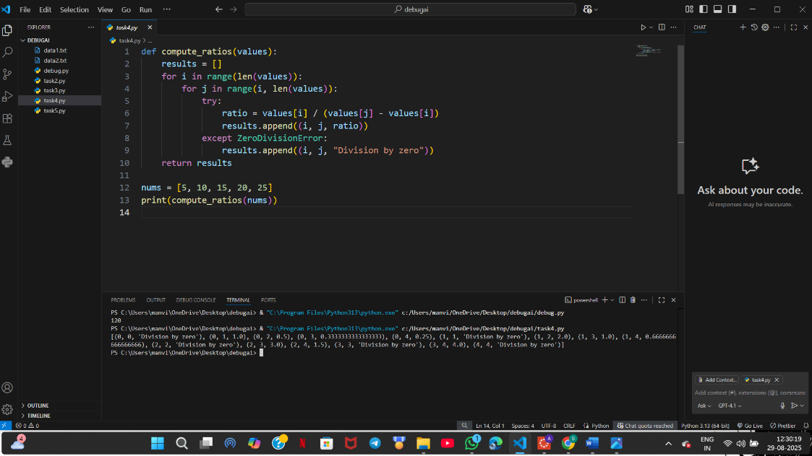

**Task Description #5:**

* Include a buggy class definition with incorrect __init__ parameters or attribute references. Ask AI to analyze and correct the constructor and attribute usage.

class StudentRecord:

def __init__(self, name, id, courses=[]):

self.studentName = names

self.student_id = id

self.courses = courseList

def add_course(self, course):

self.courses.append(course)

def get_summary(self):

return f"Student: {self.studentName}, ID: {self.student_id}, Courses: {', '.join(self.courses)}"

class Department:

def __init__(self, deptName, students=None):

self.dept_name = deptName

self.students = students

def enroll_student(self, student):

self.students.append(student)

def department_summary(self):

return f"Department: {self.dept_name}, Total Students: {len(self.student)}

s1 = StudentRecord("Alice", 101, ["Math", "Science"])

d1 = Department("Computer Science")

d1.enroll_student(s1)

print(s1.get_summary())

print(d1.department_summary())

**Expected Outcome #5:**

* Copilot identifies mismatched parameters or missing self references and rewrites the class with accurate initialization and usage.

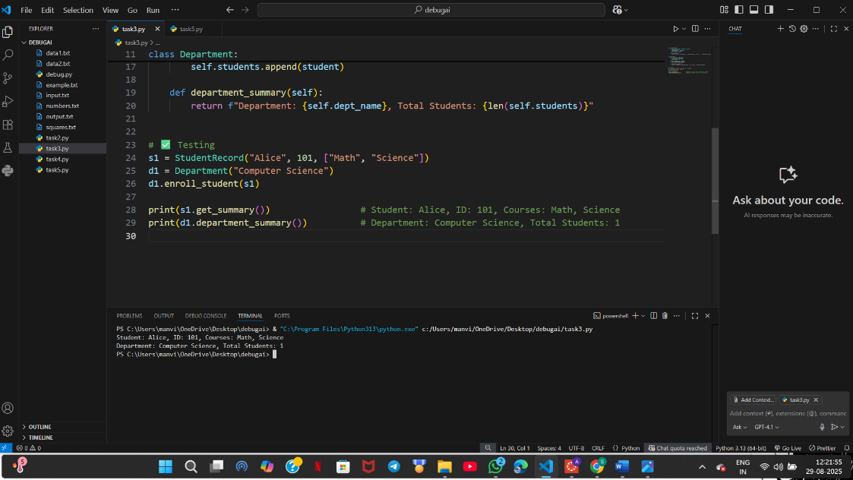

* **Observation**

Overall, the assignment reinforces core programming principles: correctness in algorithms, strict data handling, managing system resources carefully, robust error handling, safe object-oriented design, and the benefits of AI-supported debugging.

This comprehensive approach prepares developers to write reliable, maintainable, and professional Python code.